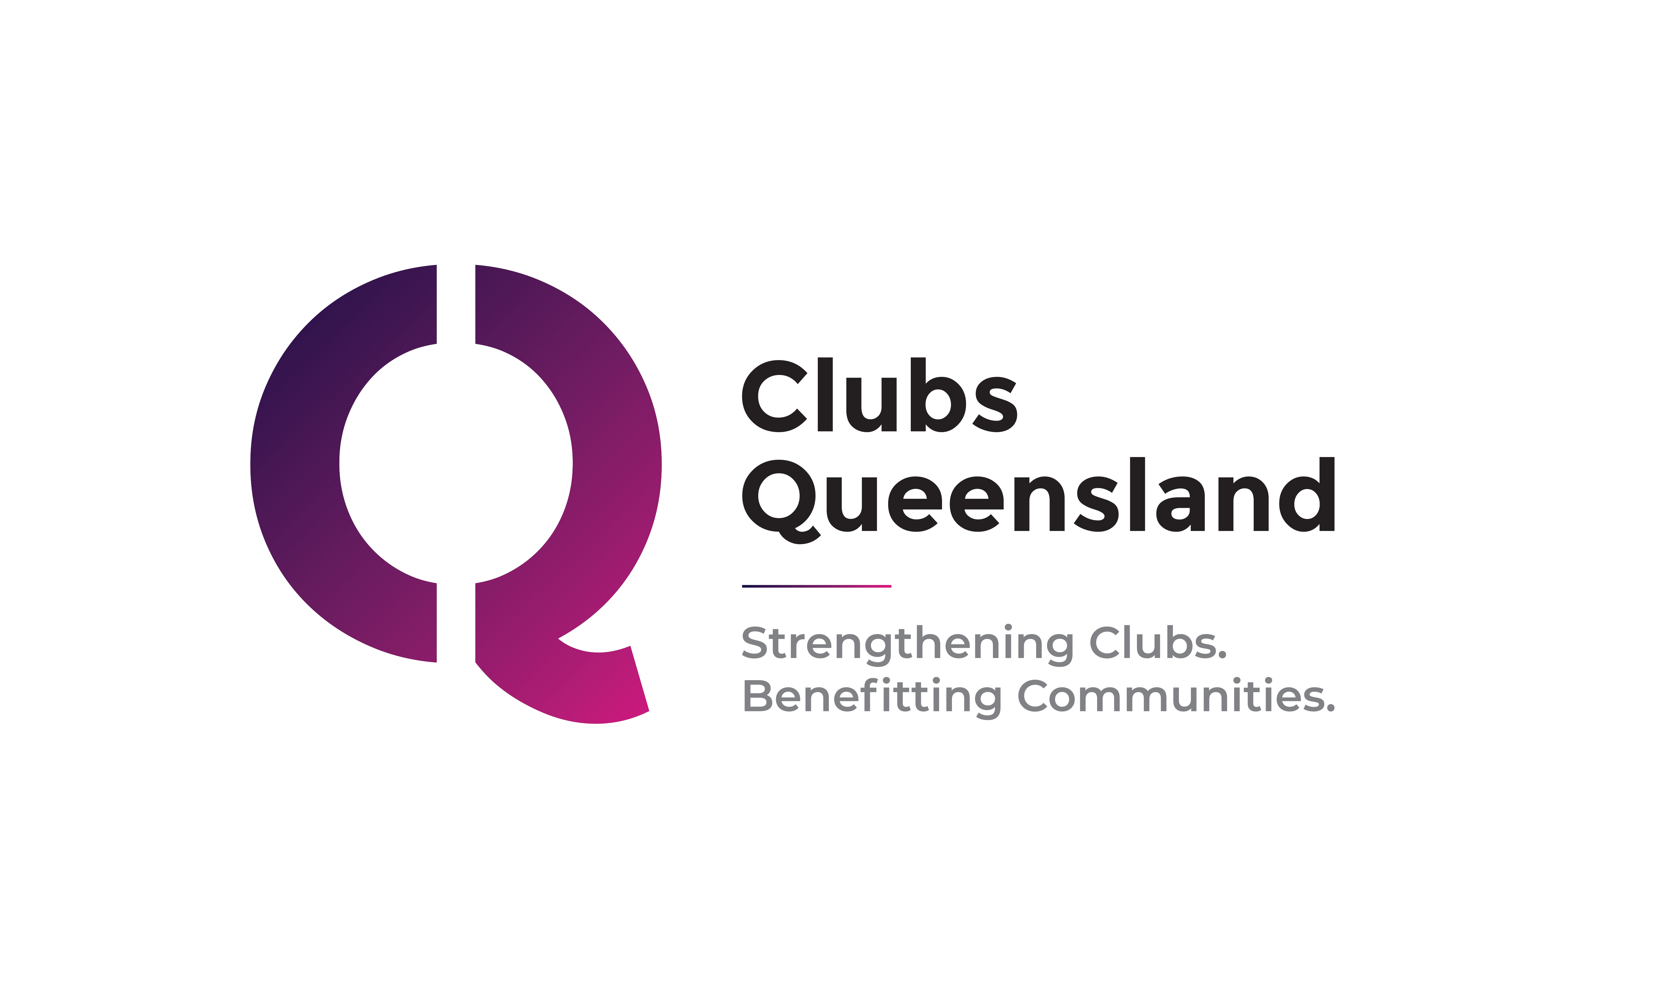

COVID-19 Privacy Collection Notice
_____________________________________________________________________________________________________

Clubs Queensland is the peak industry association and union of employers of registered and licensed community clubs in Queensland. This resource has been developed for use by member clubs only.

Please note: The template below is generic and advisory only. It is not exhaustive and requires clubs to tailor it to their individual circumstances. Clubs should document all processes and procedures so that this policy closely aligns with actual practices of the operation. A material difference between what the club says in this policy and what the club does in practice may expose the club and its officers to non-compliance and liability.

Disclaimer: The template is not legal advice and clubs should conduct their own due diligence, including obtaining independent legal and professional advice. Clubs Queensland cannot be held liable for any omissions, errors, actions or decisions made on the basis of the information contained in this resource.

Clubs Queensland acknowledges the assistance of Clubs Australia in the preparation of this policy.

© 2021 Clubs Queensland
All rights reserved. Except for purposes defined under the Copyright Act 1968, this publication must not be reproduced in part or full without written permission from Clubs Queensland. A limited exemption applies to member clubs of Clubs Queensland.

For assistance or clarification, please contact the Workplace Relations and Compliance Team - t: (07) 3252 0770, or visit www.clubsqld.com.au.
_________________________________________________________________________________________________________________________________________________________________________________________________________
COVID-19 Vaccination Information Collection Notice of [insert club name]
- Purpose
  - This COVID-19 Vaccination Collection Notice (this Notice) is issued pursuant to Australian Privacy Principle 5 in Schedule 1 to the Privacy Act 1988 (Cth) (Privacy Act). [Clubs with annual revenue of less than $3 million are directed to delete this sentence as the Australian Privacy Principles do not apply to these clubs.]
- Who is collecting and storing this information?
  - Your vaccination information is being sought by [insert Club] (the Club), located at [insert location], ABN [insert]. For any queries, please contact [insert primary contact number].
- What information is the Club collecting?
  - The Club is seeking to collect your “vaccination information” which includes one of the following two types of documentation:
- Evidence from the Australian Immunisation Register (operated by the Commonwealth Government) that you have had 1 or 2 doses of a COVID-19 vaccine; or

- A medical certificate issued by a medical practitioner that certifies that you are unable to have the COVID-19 vaccine because of a specified medical contraindication.

  - This information is “sensitive information” under the Privacy Act which is subject to a high level of privacy protection.
- Consent
  - The Privacy Act requires the Club to obtain your consent to collect your vaccination information. [Clubs with annual revenue of less than $3 million are not subject to this requirement, and may replace this sentence with: “The Club is seeking your consent because this information is sensitive personal information.”]
  - If you consent to this COVID-19 Vaccination Collection Notice, you are confirming that as an employee of the Club, you agree that the Club has notified you of the purposes of collecting your vaccination information and that:
    - You understand how the Club will collect and handle your vaccination information in accordance with this Notice and the Club’s privacy policy [Clubs with annual revenue of less than $3 million who do not have a privacy policy are advised to delete all references to a privacy policy]; and
    - You acknowledge that you are providing this consent voluntarily.
  - At the end of this Notice, you have an opportunity to consent to providing the Club this information.
- Who does this notice apply to?
  - This Notice applies to all employees of the Club, as well as volunteers, in conjunction with its privacy policy and procedures. [Clubs with annual revenue of less than $3 million who do not have a privacy policy are advised to delete all references to a privacy policy]
- Who do we collect the information from?
  - The Club is seeking to collect your vaccination information directly from you.
- Why is the Club collecting COVID-19 vaccination information?
  - The Club is seeking to collect your vaccination information because:

    - The Delta variant of the coronavirus, which is currently circulating throughout Australia, is highly transmissible and infectious and capable of causing hospitalisation and death to people who are exposed, and
    - The COVID-19 vaccines approved by the Therapeutic Goods Administration (TGA) of the Commonwealth are currently our most effective “first line of defence” at limiting the transmission of COVID-19, as stated by the Australian Technical Advisory Group on Immunisation (ATAGI), and
    - Having records of your vaccination information will enable the Club to comply with its obligations under the law.
- Consequences of the Club not collecting your vaccination certificate.
  - If the Club is unable to collect your vaccination information, it will hinder the Club’s capacity to comply with the law.
- Who are the types of bodies and persons to whom we may disclose your vaccination information?
9.1 The Club will only disclose your vaccination information in accordance with any obligation or duty imposed on the Club by an order under the Public Health Act or any other law.
- Will my vaccination information be disclosed to overseas recipients?
10.1 No, the Club will not disclose your vaccination record to any overseas recipient.
- How will records of my vaccination information be stored?
  - The Club may record your vaccination information in hard copy and electronic formats. [Insert if relevant: In some cases, the club engages third parties to host electronic data on its behalf to store employee records and data.]
  - The Club will take all reasonable steps to protect your vaccination information from misuse, loss or alteration. These steps include but are not limited to [note: insert or delete information as necessary and applicable]:
    - requiring security passes to enter the office or areas within the office where hard or electronic copies are accessible
    - keeping hard copies in in locked cabinets,
    - storing the information in a database on a cloud which is routinely checked and audited;
    - implementing technological controls – for example, restriction of access, firewalls, use of encryption and passwords;
    - destroying the information once the Club no longer needs to hold it (if hard copy – by shredding, and if soft copy – by deleting or permanently de-identifying); and
    - if hard copies of the information are removed from the Club – requiring that they be placed in a plain manila folder which does not identify the person.
11.3 The Club will destroy the information when the purposes for which it was collected are no longer relevant. The information may be retained to comply with any legal or regulatory requirements introduced after this Notice is issued.
- How can I access my COVID-19 vaccination record?
  - The Club will take reasonable steps to ensure that the Personal Information and/or Sensitive Information it collects, uses, holds or discloses is accurate, complete and up-to-date.
  - Employees will be allowed access to their COVID-19 vaccination record held about them upon request, unless that access would pose a threat to health and safety of any individual or would unreasonably impact on the privacy of another person.
  - Reasonable steps will be taken to correct any information if it is shown to be inaccurate, incomplete or out-of-date.
- Ensuring the information we hold is accurate.
  - The Club endeavours to ensure that your vaccination information is kept as current as possible.
  - If you send the Club a vaccination certificate evidencing you have received one dose of the COVID-19 vaccine, you should notify the Club as soon as practicable once you have received your second dose of the vaccine, so your records are up to date and accurate.
  - Employees are encouraged to request that their vaccination information be corrected if it is inaccurate, out-of-date, incomplete, irrelevant or misleading and the Club will update the information if satisfied this is the case. Requests for updating your vaccination information must be in writing and all requests will be responded to within a reasonable timeframe.
- Can I make a complaint about how my data is handled?
14.1 If you are concerned your vaccination information has been collected, used, disclosed or otherwise handled in a manner which is inconsistent with this Notice or the Club’s privacy policy, you are able to make a complaint to the Club by contacting [name and contact details of person who will receive the complaint]. [Clubs with annual revenue of less than $3 million who do not have a privacy policy are advised to delete all references to a privacy policy]

- Signed consent by the employee
I, [insert full name], confirm that I have read and understood this Notice. I understand and accept how the Club will collect and handle my vaccination information in accordance with this Notice and the Club’s privacy policy and I acknowledge and agree that I am providing this consent voluntarily. [Clubs with annual revenue of less than $3 million who do not have a privacy policy are advised to delete all references to a privacy policy]

Full name of employee: ……………………………………….

Signature of employee: ……………………………………….

Date: ……………………………………….

